Tab 1

# **Research Papers on Rainfall Prediction Using Machine Learning Summary**

# **1. A Comparative Study of Machine Learning Models for Daily and Weekly Rainfall Forecasting**

## **Key Points from the Abstract**

* **Objective:** 
  + Improve rainfall forecasting accuracy for Delhi by analyzing regional climate influences from neighboring states (Uttarakhand, UP, Haryana, Punjab, Himachal Pradesh, MP, Rajasthan).
* **Data Used:**
  + Historical rainfall data (1980–2021) from neighboring states.
  + Dual-model approach:
    - Daily model → Immediate rainfall triggers.
    - Weekly model → Longer-term trends.
* **Machine Learning Models Used:**
  + CatBoost, XGBoost, ElasticNet, Lasso, LGBM, Random Forest, MLP, Ridge, SGD, Linear Regression.
* **Key Findings:**
  + Daily Rainfall Forecasting: CatBoost, XGBoost, and Random Forest performed best.
  + Weekly Rainfall Forecasting: XGBoost achieved near-perfect accuracy (R² = 0.99), followed by Random Forest and CatBoost.
* **Conclusion:** 
  + The study enhances Delhi’s rainfall prediction accuracy by incorporating regional climate patterns, improving timely and reliable forecasts**.**

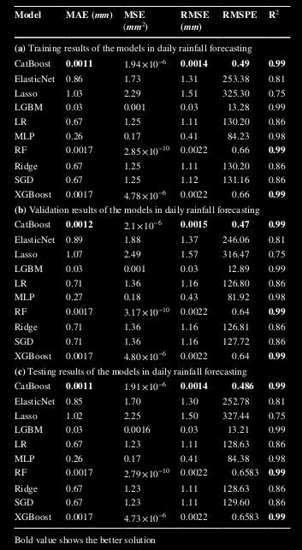

## **Key Points from the Conclusion**

* **Objective:** 
  + Evaluated rainfall forecasting models using historical data from Delhi and neighboring states (Uttarakhand, UP, Haryana, Punjab, Himachal Pradesh, MP, Rajasthan).
* **Daily Rainfall Forecasting:**
  + CatBoost performed best (R² = 0.99, RMSE = 0.0014, MAE = 0.0011).
  + XGBoost & Random Forest (RF) also performed well (R² = 0.99, RMSE = 0.0022, MAE = 0.0017).
  + Lasso Regression had lower accuracy (R² = 0.75, RMSE = 1.50, MAE = 1.02), struggling with detailed rainfall patterns.

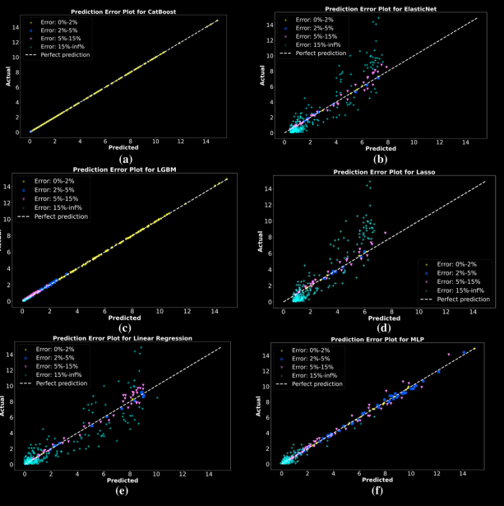

* **Weekly Rainfall Forecasting:**
  + XGBoost was the best model (R² = 0.99, RMSE = 0.10, MAE = 0.019).
  + RF and CatBoost also showed strong performance (R² = 0.99, RMSE ≈ 0.11–0.12, MAE ≈ 0.03–0.06).
* **Key Findings:**
  + Advanced ML models (XGBoost, CatBoost, RF) significantly improve rainfall prediction accuracy.
  + Accurate rainfall forecasts are crucial for:
    - Agriculture
    - Water resource management
    - Flood control
    - Urban planning
  + Better understanding of regional climate patterns enhances weather forecasting for Northern India.

## **2. Rainfall Prediction: A Comparative Analysis of Modern Machine Learning Algorithms for Time-Series Forecasting**

### **Key Highlights**

* **Importance of Rainfall Forecasting:** Crucial for flood prediction and pollution monitoring.
* **Challenges with Traditional Models:** Costly and inefficient statistical models.
* **Alternative Approach:** Machine Learning (ML) and Deep Learning (DL) techniques for time-series forecasting.

### **Models Compared**

* LSTM
* Stacked-LSTM
* Bidirectional-LSTM
* XGBoost
* Ensemble model (Gradient Boosting Regressor, Linear SVR, and Extra-trees Regressor)

### **Dataset & Evaluation Metrics**

* **Dataset:** Climate data (2000–2020) from five UK cities.
* **Metrics:** Loss, RMSE, MAE, RMSLE.

### **Key Findings**

* **Top Performing Models:** Bidirectional-LSTM and Stacked-LSTM.
* **Efficiency:** LSTM models with fewer hidden layers perform better.
* **Application:** Suitable for budget-friendly rainfall forecasting.

### **Conclusion**

* **Objective:** Compared rainfall forecasting models using LSTM networks and modern ML algorithms.
* **Best Models:** Stacked-LSTM (Model 4) and Bidirectional-LSTM (Model 6).
* **Major Drawback:** Overfitting in training data.
* **Future Work:** Fine-tuning hyperparameters, exploring hybrid models, and integrating more weather factors.

## **3. Comparative analysis and enhancing rainfall prediction models for monthly rainfall prediction in the Eastern Thailand .**

### **Objective**

* Evaluated rainfall prediction models using the Oceanic Niño Index (ONI) as a predictor.
* Optimized lag time to improve predictions.

### **Models Compared**

* RNN with ReLU
* LSTM (single-layer)
* GRU (single-layer)
* LSTM+LSTM (multi-layer)
* LSTM+GRU (multi-layer)

### **Findings**

* **Performance Metrics:** MAE, RMSE.
* **Hybrid Model Performance:** Improved accuracy across different climate phases (El Niño, La Niña, Neutral).
* **Limitations:** Spatio-temporal variability affects accuracy.

### **Future Research**

* Enhancing hyperparameter tuning.
* Standardizing input data for better adaptability.

## **4. Comparative Analysis of Rainfall Prediction Models Using Machine Learning in Islands with Complex Orography: Tenerife Island**

### **Objective**

* Compared ML models for monthly rainfall prediction in a region with complex terrain.

### **Challenges**

* Traditional models have low accuracy for mid-term rainfall forecasting in such regions.

### **Models Evaluated**

* Random Forest (RF)
* Extreme Gradient Boosting (XGBoost)

### **Dataset**

* Weather data from two meteorological stations.
* NOAA reanalysis predictors.
* North Atlantic Oscillation Index (NAO) (Global predictor).
* Over 40 years of historical data.

### **Key Findings**

* **Important Predictors:** Local Geopotential Height (GPH) was more influential than the NAO Index.
* **Effectiveness:** ML models (RF, XGBoost) performed well for mid-term precipitation forecasting.

### **Future Work**

* Investigating LSTM networks for time-series forecasting.
* Real-time ML applications using weather station streaming data.

## **5. Analyzing and predicting rainfall patterns: A comparative analysis of machine learning models**

### **Objective**

* Investigated the effectiveness of ML models for rainfall prediction.

### **Models Evaluated**

* Linear Discriminant Analysis (LDA)
* Support Vector Machine (SVM)
* K-Nearest Neighbors (KNN)
* Naïve Bayes (NB)

### **Findings**

* **Best Model:** SVM achieved 0.98 accuracy and a 0.95 Kappa statistic.
* **Impact of ML:** Improved decision-making in agriculture and disaster preparedness.

### **Future Research**

* Exploring ensemble methods for better accuracy.
* Integrating real-time data streams.
* Using alternative data sources (satellite imagery, sensors, social media).

## **6. Machine Learning Techniques for Rainfall Prediction: A Review**

### **Importance of Rainfall Prediction**

* Affects economy and human life.
* Essential for disaster prevention (floods, droughts).
* Crucial for agriculture-dependent countries like India.

### **Challenges in Rainfall Estimation**

* Traditional statistical models struggle due to atmospheric dynamics.
* Heavy precipitation remains difficult to predict accurately.

### **Key Findings**

* **Artificial Neural Networks (ANNs):** Most effective for handling nonlinear rainfall data.
* **Support Vector Regression (SVR):** Effective for long-term rainfall forecasting.

### **Future Directions**

* Hybrid models combining multiple ML techniques.
* Real-time ML applications.
* Expanding datasets for better generalization.

**________**

# **7. Prediction of Rainfall Using Machine Learning Techniques**

## **Key Points from the Abstract**

* **Importance of Rainfall Prediction:**
  + Essential for disaster prevention (floods, droughts).
  + Helps in taking preventive measures.
  + High accuracy is crucial, especially for agriculture-dependent countries like India.
* **Types of Rainfall Prediction:**
  + Short-term prediction → More accurate.
  + Long-term prediction → More challenging to model accurately.
* **Challenges:**
  + Heavy precipitation prediction is difficult due to its economic and human impact.
  + Traditional statistical techniques struggle due to the dynamic nature of the atmosphere.
* **Proposed Approach:**
  + Machine learning techniques, particularly regression models, offer better accuracy.
  + The project aims to simplify rainfall prediction techniques for non-experts.
  + Comparative study of different machine learning methods for precipitation prediction.

## **Key Points from the Conclusion**

* **Objective:** Focused on rainfall estimation using Support Vector Regression (SVR).
* **Key Findings:**
  + SVR is a valuable and adaptable technique for rainfall prediction.
  + It helps in overcoming challenges related to:
    - Distributional properties of variables.
    - Data geometry.
    - Model overfitting.
  + Choice of Kernel Function is Crucial:
    - Linear kernel for linear relationships.
    - RBF (Radial Basis Function) kernel for nonlinear relationships.
* **Comparison with Multiple Linear Regression (MLR):**
  + SVR outperforms MLR in capturing non-linearity in the dataset.
  + MLR is less effective in complex rainfall prediction scenarios.

# **8.Rainfall Prediction System Using Machine Learning Fusion for Smart Cities**

## **Key Points from the Abstract**

* **Objective:** 
  + Develop a real-time rainfall prediction system for smart cities using a machine learning fusion technique.
* **Challenges:**
  + Rainfall prediction is difficult due to extreme climate variations.
  + Selecting the best classification technique for prediction is complex.
* **Proposed Approach:**
  + **Uses four supervised ML techniques:**
    - Decision Tree
    - Naïve Bayes
    - K-Nearest Neighbors (KNN)
    - Support Vector Machines (SVM)
  + **Fusion Technique:**
    - Incorporates Fuzzy Logic to combine the predictive strengths of different ML models.
* **Dataset:**
  + 12 years of historical weather data (2005–2017) from Lahore.
  + Data was cleaned and normalized before classification.
* **Key Findings:**
  + The fusion-based ML framework outperforms other individual models.
* **Application: Useful for smart cities, big data applications, and hydrological modeling.**

## **Key Points from the Conclusion**

* **Objective:** Developed a real-time rainfall prediction system for smart cities using machine learning fusion.
* **Key Contributions:**
  + Integrated Decision Tree, Naïve Bayes, KNN, and SVM for rainfall prediction.
  + Fuzzy logic was used to fuse the accuracy of multiple ML models.
  + 12 years of historical data (2005–2017) from Lahore was preprocessed (cleaning, normalization).
  + Achieved higher accuracy than traditional ML techniques.
* **Limitations:**
  + Data integrity issues (sensor malfunctions or compromised data affect predictions).
  + Monitoring system needed to ensure weather sensors function correctly.
* **Future Work:**
  + Exploring ensemble ML techniques for diverse datasets.
  + Implementing feature selection for cost-effective predictions.
  + Extending ML fusion to temperature prediction for solar energy applications.
  + Incorporating Artificial Neural Networks (MLP, LSTM) for improved forecasting.